**Samsung WW90KQX Washing Machine**

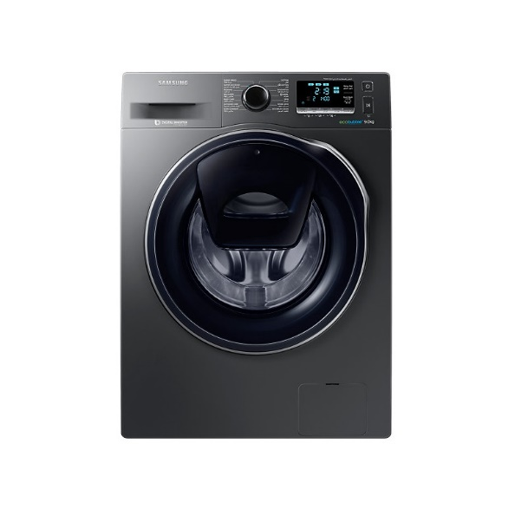

|  |  |  |  |
| --- | --- | --- | --- |
|  | **Washing Capacity(kg):** | 9 kg |  |
| **Body Color:** | Fixe1Inox |
| **Door:** | Crystal Gloss |
| **Panel Type:** | LED |
| **AddWash:** | Yes |
| **Bubble Soak:** | Yes |
| **Bubble technology:** | Yes |
| **Child Lock:** | Yes |
|  | **Delay End:** | Yes |  |
|  | **Quick Wash:** | Yes |  |
|  | **Spin Speed:** | 1400rpm |  |
|  | **Smart Check:** | Yes |  |